JNDI means Java Naming & Directory Interface.

When we deploy an application in tomcat. It interacts with some other servers. It could be DB or SFTP or kafka etc.

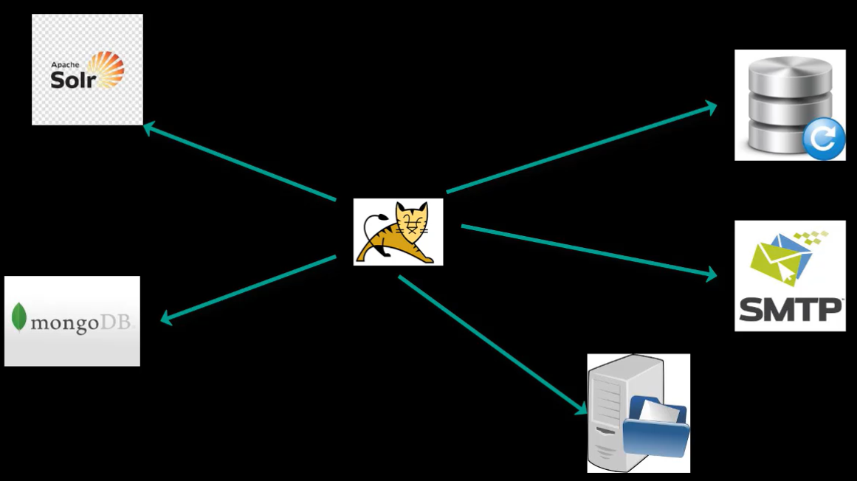

Whenever any configuration changes happen, we need to restart the server.

We can keep all those configuration details inside a table called JNDI.

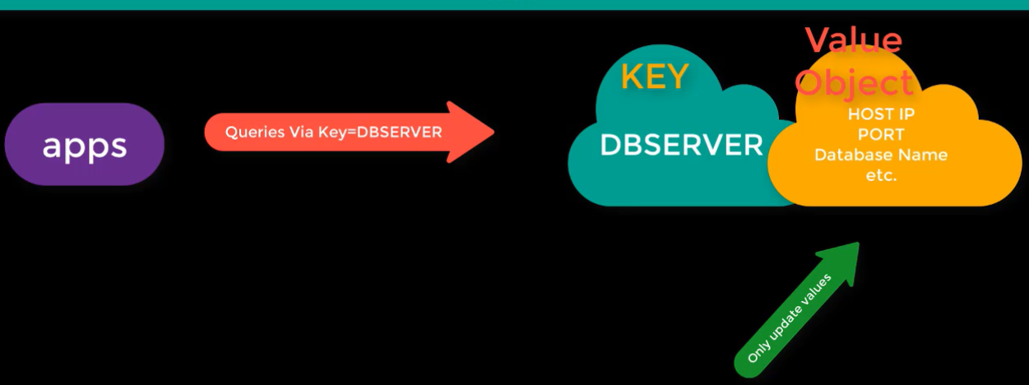

Let’s say we update the DB server details in JNDI. So everytime we need a change in db details. We change the value not key

Connection pooling:

Let’s say if java application makes a connection to DB and executes a query. Once the query is executed, the connection will be closed, and the memory allocated for that will be free.

And if another user requests again, it will create a new connection to DB again.

Every time creating a new connection is a time-consuming process and there will be impact on the performance as well.

Tomcat provides a provision to create a connection pool. So that user request need not to create the connection again. It can take the connection object from the pool which is already created.